**OLED DIMENSIONS**

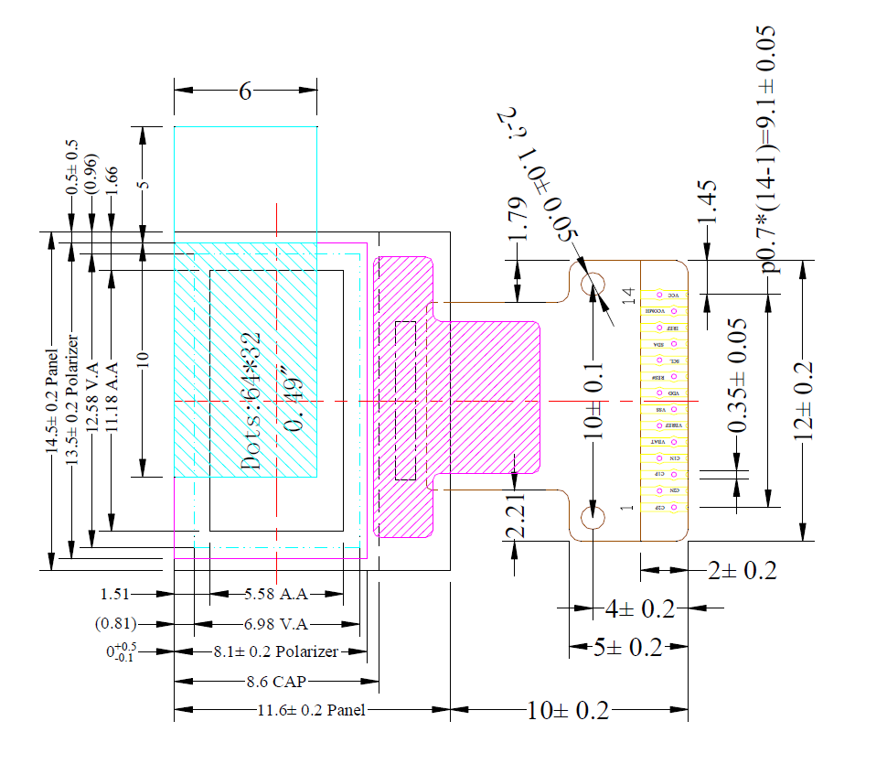

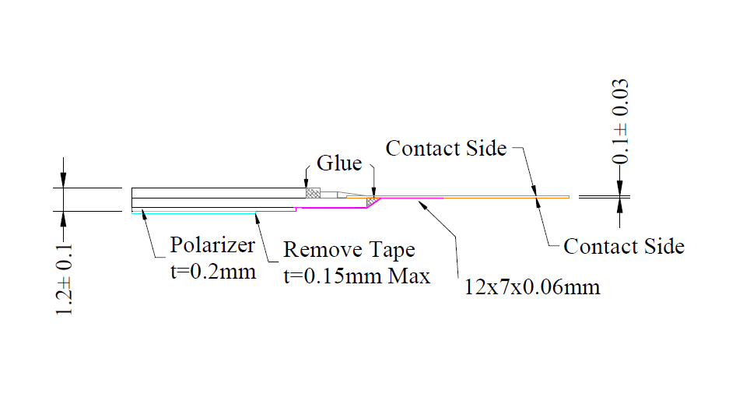

**Keyboard and Keys Dimensions**

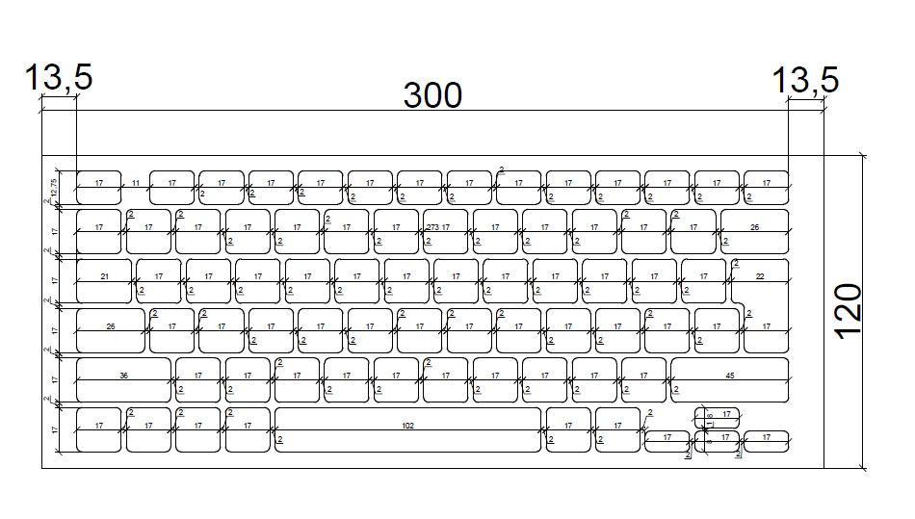

* 1st Key 17x12.75 mm (QTY 14)
* 2nd Key 17x17 mm (QTY 54)
* 3rd Key 21x17 mm (QTY 1)
* 4th Key 26x17 mm (QTY 2)
* 5th Key 36x17 mm (QTY 1)
* 6th Key 45x17 mm (QTY 1)
* 7th key 102x17 mm (QTY 1)
* 8th Key 17x8 mm (QTY 4)
* **17x8 mm Arrow Key Size is very small if we use 0.49 INCH LED?**

**Need to Be discuss Pls,**

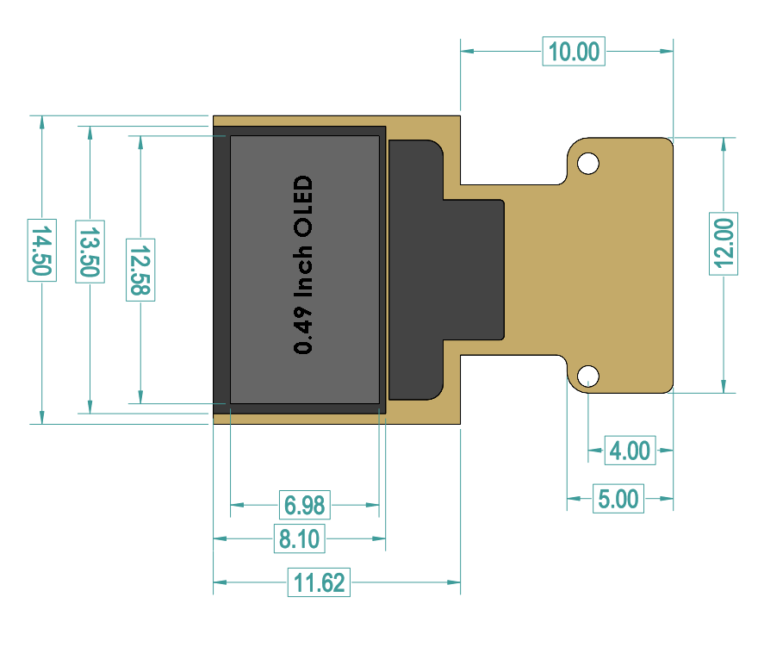**Modeled OLED with Specs**

* **Proposed Size of the PCB for OLED is 14.50x11.62??**
* **Size 14.50x11.62 will be inserted in the Key?**
* **We Have Smallest size of Key is 17x12.75mm**

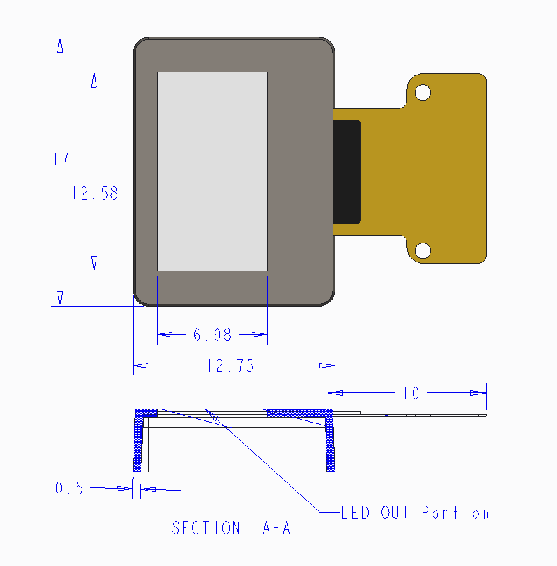

* **Need to Know about the bend radius of Flexible Yellow strip of OLED?**
* **Thickness of the Key is not 0.5 mm; it will be decided after different calculations on thickness.**